**ArcGIS Pro project file**

**\\files\maps\!Web Map MXDs\WebMapPro\WebMapPro.aprx**

Use for updating shared layers, PACS, the Harris-Govern web map.   
The project file has four tabs:

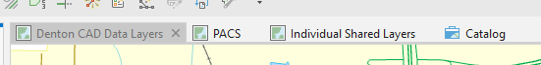

* Denton CAD Data Layers currently is not used but can be used in the future for a web map if Harris Govern’s web map is ever replaced.
* PACS mirrors the PACS GIS map
* Individual Shared Layers are those that are shared as services on the server

(Users may need to re-link layers from their own server connections)

**To Export Data for Public Download***\*it should be a priority to automate this- see python script export.ipynb in this folder*

Parcels must be joined and exported, and some extraneous fields deleted. Join parcels to the map_public table by prop_id and keep all records.

Export joined parcels to the existing geodatabase and overwrite:  
\\files\cadnet\datafiles\gis\Data Export\nightly_geodatabase.gdb

Use the delete field geoprocessing tool to delete the fields *created_user, created_date, last_edited_user, last_edited_date, prop_id_1*

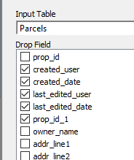

Use the table to table geoprocessing tool to export the parcel feature class to a table called Appraisals and overwrite.

This geodatabase contains Parcels and Subdivision feature classes and one table. The table is used for users who need to see appraisal data that may not be in a polygon (UDI, Condos, etc.)

Export the parcel feature class in the geodatabase to a shapefile:  
\\files\cadnet\datafiles\gis\Data Export\parcels.shp  
  
Also, at this time, export roads to a shapefile for CAMA Cloud.

Now, all of the data in the folder is formatted correctly to be exported and shared.   
  
Zip the gdb folder and overwrite \\files\cadnet\datafiles\gis\nightly_geodatabase.gdb.zip to update the website download.

**To Upload Data to CAMA Cloud**

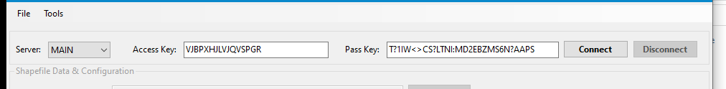

Access Key: VJBPXHJLVJQVSPGR  
Pass Key: T?1IW<>CS?LTNI:MD2EBZMS6N?AAPS  
  
The parcels shapefile contains CAMA data here, but it doesn’t affect the upload (it only seems to upload the prop_id field and the polygon data). Upload parcels and roads.

**To Update the Web Map Parcel Layer**

Open the ArcGIS Pro project \\files\maps\!Web Map MXDs\WebMapPro\WebMapPro.aprx  
Open the Individual Shared Layers. The web data is shared from the shapefile sourced in the data export folder.

Right click on Parcels_with_CAMA_Data and go to sharing and then overwrite. Overwrite the existing parcels_with_CAMA_Data service in the public folder on the portal.

This copies data to the server and overwrites any old data.

**Web Map Pop-Up format**

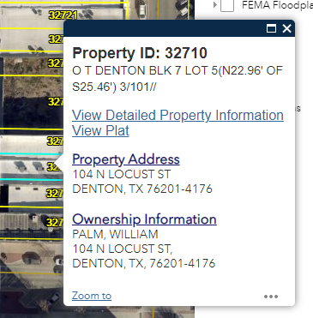

**Property ID: {prop_id}**  
{legal_desc}  
  
[View Detailed Property Information](https://propaccess.trueautomation.com/clientdb/Property.aspx?cid=19&prop_id=%7Bprop_id%7D)*(link configured as:*[*https://propaccess.trueautomation.com/clientdb/Property.aspx?cid=19&prop_id={prop_id}*](https://propaccess.trueautomation.com/clientdb/Property.aspx?cid=19&prop_id=%7Bprop_id%7D)*)*[View Plat](https://www.dentoncad.com/plats/%7Babs_subdv_cd%7D.tif) *(link configured as:*[https://www.dentoncad.net/data/_uploaded/plats/{abs_subdv_cd}.tif](https://www.dentoncad.net/data/_uploaded/plats/SK3449A.tif))  
  
**Property Address**  
{situs}   
  
**Ownership Information**  
{owner_name}  {addr_line1}  
{addr_line2}, {addr_line3}  
{addr_city}, {addr_state}, {addr_zip}

**Logins**

Portal : <https://geo.dentoncad.com/arcgisportal/home/>  
User: portaladmin Password: wadi.calvin.618assure7

**Server Setup**

Queries from PACS can be saved as replicated tables in the GIS server, ask IT! It’s easier to start all mapping tables with “map_” to make them easier to find.

**Portal**

Public data is stored on the portal in the “Public” folder. When you share parcels_with_CAMA_data and choose the public folder, it will place it in the “hosted” folder instead – that’s okay.

**Geodatabase Maintenance**

It’s important to compress the geodatabase periodically and to delete every version and rebuild them. I do this on Tuesdays once a month (I missed December). If you don’t want to delete the versions, you can still just right click on the geodatabase connection and go to administration and then compress.

**To Export Roads (Arcgis Desktop)**

Add roads to your MXD, or open an MXD with roads already added.

Right click on the roads in the table of contents, and go to *Data*, *Export Data…*

For the export directory, choose \\files\cadnet\datafiles\gis\Data Export

Call the exported data roads.shp and overwrite the roads that are already in there. The Save as Type is shapefile.

Click Save, Yes, OK

Now if you go to \\files\cadnet\datafiles\gis\Data Export you will see the new roads shapefile, with 7 or 8 files. Select all the files called “Roads” and zip them.

(To zip, right click on all the roads files and click send to… compressed (zipped) folder)

Drag the zip file up to the address bar and place in gis directory, and overwrite what’s already in there.

**To Export Roads (CAMA Cloud)**

Open CAMA Cloud MapLoader. Click Connect.

Select Shapefile, and choose \\files\cadnet\datafiles\gis\Data Export\roads.shp (the one that you just made)

Select Shape Type = Street  
Unique ID Field = ObjectID  
Street name field = name

Click start transfer.

WAIT